**Intro**

This function allows us to generate the Sierpinski Triangle and explore other recursive shapes with equal length sides following the same algorithm.

shape <- function(corners, trials = 100000){

corners <- as.integer(corners)

points <- list()

if (corners < 3) stop("Value should be 3 or greater")

for (n in 1:(corners)){

points$x[n] <- 0 + cos((2*pi*n)/corners)

points$y[n] <- 0 + sin((2*pi*n)/corners)

}

x <- points$x[1]

y <- points$y[1]

trials <- trials

sierpinski <- list()

for (t in 1:trials){

r <- sample(1:corners,1)

x <- (x + points$x[r]) / sqrt(corners + 1)

y <- (y + points$y[r]) / sqrt(corners + 1)

sierpinski$x[t] <- x

sierpinski$y[t] <- y

}

# I use these colors for random color selection. Update for your own desired selection.

color <- sample(c("royalblue2", "firebrick2", "gold2", "springgreen3", "purple2", "darkorange1"),1)

plot(sierpinski$x[corners:trials], sierpinski$y[corners:trials],

xlab = paste0(corners, " Sides Chosen"), ylab = "", xaxt = "n", yaxt = "n", col = color)

}

When you run the function, you indicate the number of sides for the polygon and adjust the number of trials to change the resolution if desired. Here are some examples:

shape(3)

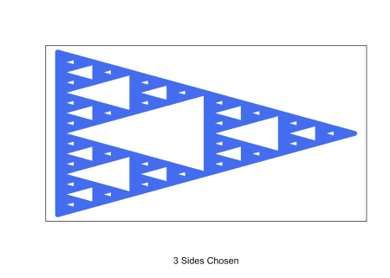

shape(4)

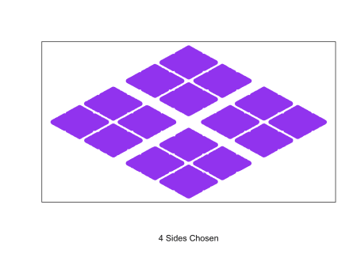

shape(6)

